AERO1005 MATLAB Coursework 2

Author: Ruixuan ZOU
Student ID: 20719241
Date of report: Add submission date here

For questions which require you to write text (i.e., descriptive sentences), or include images and graphs, please add them to the Word submission template.
TASK 1: READ TEMPERATURE DATA, PLOT, AND WRITE TO A LOG FILE
- Set up of thermistor
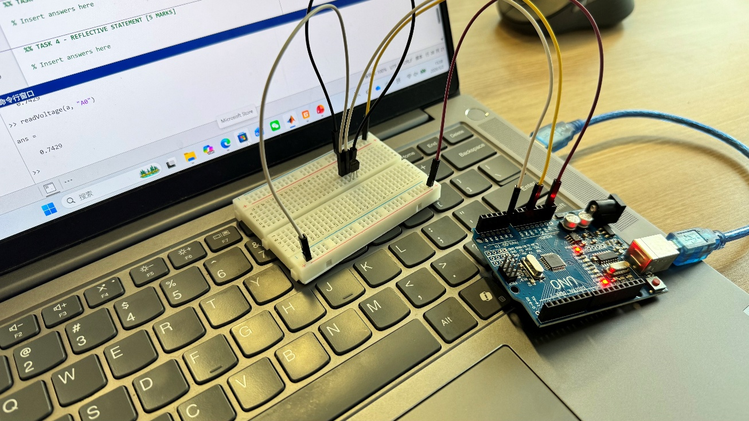
- Temperature/time plot
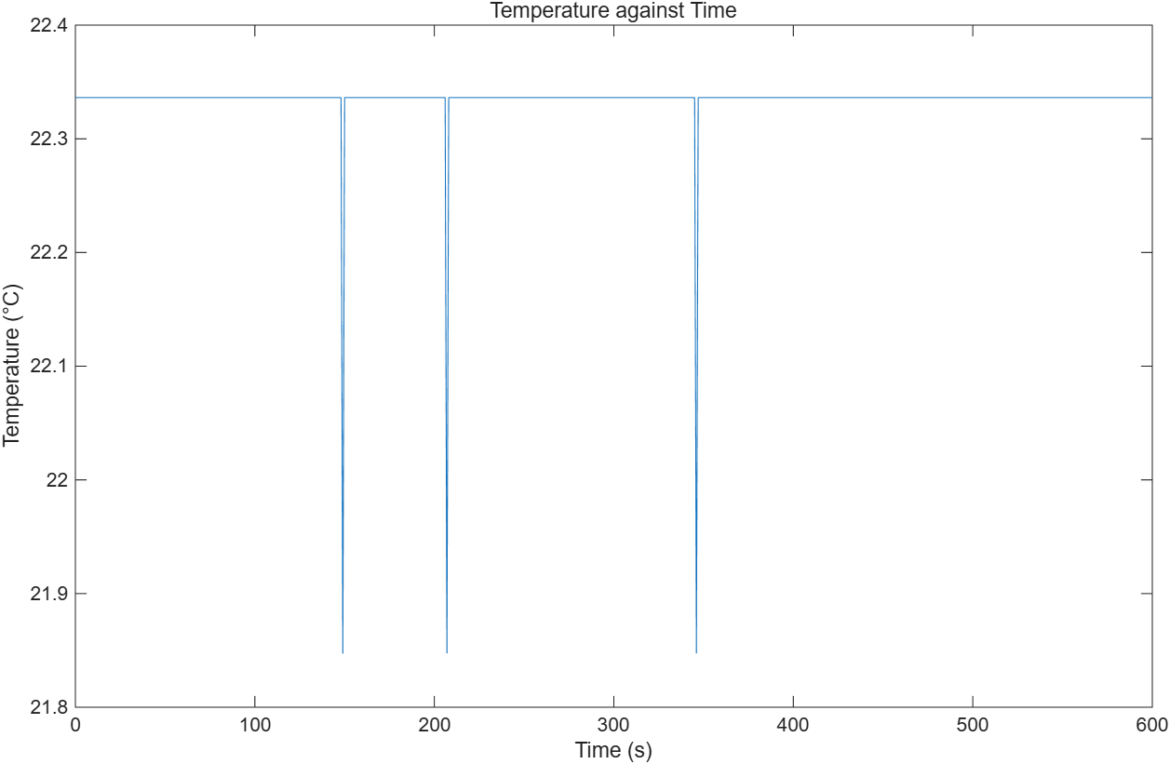

TASK 2:
- Flowchart
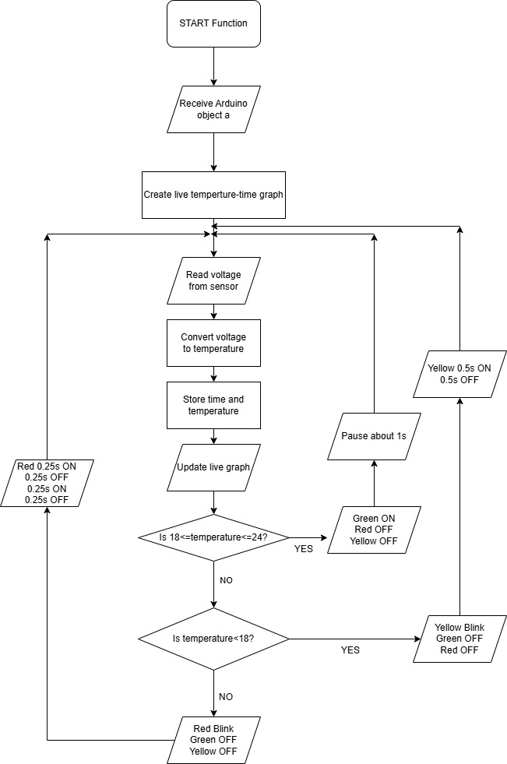

- Thermistor Version 2 Setup
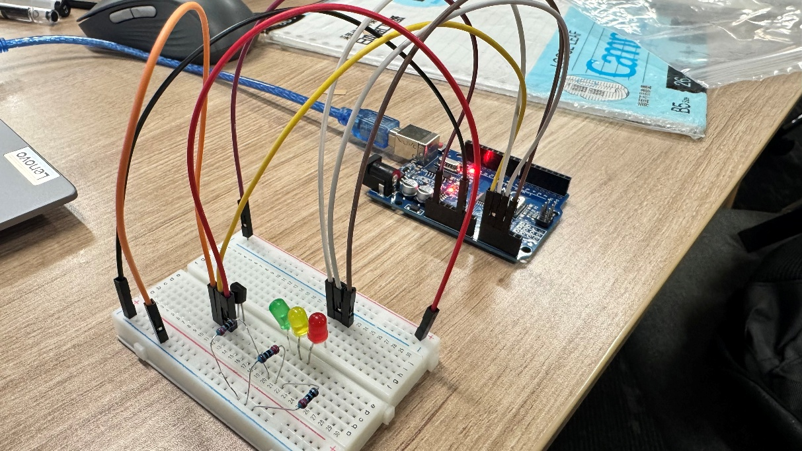

- Temperature monitor test plot
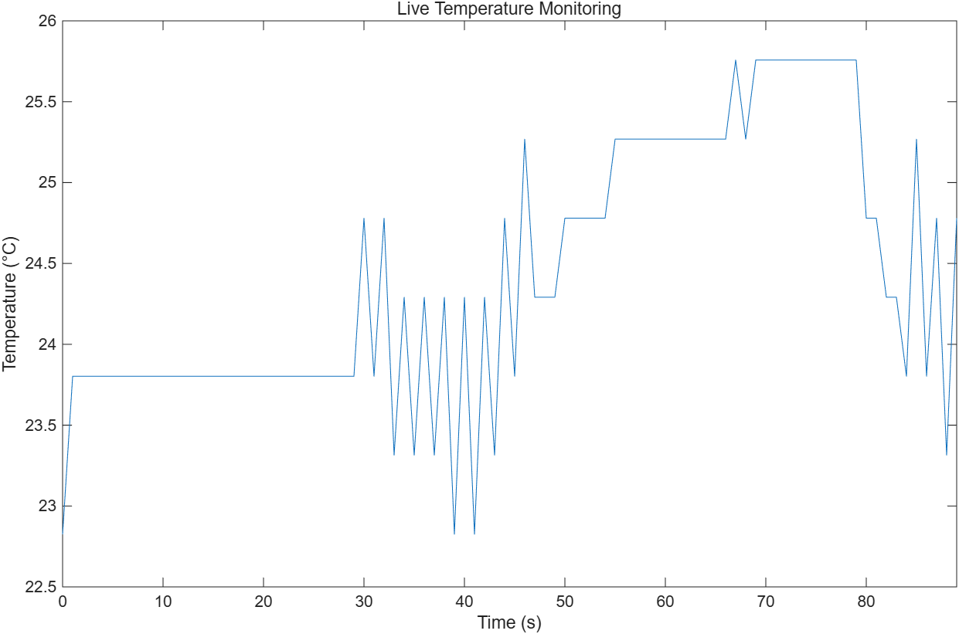

- Flowchart after finish
